Please write a “Google review”
Your Company Logo
Your Company Name
(takes ~ 3 minutes)

Do you have a Gmail account?

- Sign into your Gmail account then go to Google
- In the Search Box type in: Company name + City name – click enter
- Write the review (don’t forget to click “post”)
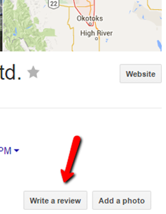
Done.
Thank YOU!

